Boiler installations
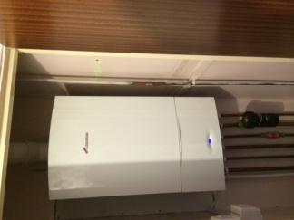

At Allstar systems we have over 12 years experience in heating systems, our heating engineers in Norwich are gas safe registered and have great knowledge on various different heating systems. We can give the best advice on which boiler would be the most efficient for yourself. If you require a new boiler in Norwich or around Norwich our engineers can be on hand as we cover all of Norfolk. Worcester Bosch is our preferred choice of boilers to be installed in most homes, they are the leading heating specialist in the market and have great reputation on efficiency and reliability. There are three main type of boilers to choose from:-
Combi Boiler:-
At Allstar systems our heating engineers in Norwich install many boilers, this one being the most popular. This boiler can offer both instantaneous hot water and Heating to the radiators . This boiler is a great choice for small households as no energy is wasted in keeping the water in a hot water cylinder.

Regular Boiler/ Heat only boiler:-
The most common type of boiler installed in most older properties. This boiler is still a great choice where you require heat to a cylinder and radiators. It can cope with larger demands for heating and models up to 40kw available.
Systems Boiler:-
As like the regular boiler but with this boiler it has some components installed within. A heating pump, expansion vessel, pressure relief are the main components installed within this boiler.

Our gas safe registered engineers Norwich can work out the correct size boiler for your requirements. We take in consideration weather you are extending on to your property in the future or not. As this can be vital so that you don't have to worry about upgrading to a larger boiler in the future. We have vast knowledge and experience with Worcester Bosch boilers regarding their heat outputs. We can offer you great advice and ways to save large amounts on your energy bills.
All Worcester Bosch Boilers installed by Allstar systems comes complete with a 5 year warranty. The main primary heat exchanger within the boiler is covered with a 10 year warranty. All heating systems where a new boiler is being installed are power flushed prior as standard. This is to make sure the system is clean from any impurities such as iron oxide which can be very corrosive and damage your new boiler. This also helps circulation problems within the system and can be vital on energy saving.

Links to types of boilers, Radiators and towelrails, Heating system upgrade

Above are some links relating to heating system upgrades within this site which might helpful to you. All jobs undertaken by Allstar systems are planned prior work commencing and taken out at the most efficient way possible. Minimum disturbance is made where possible and cleanliness is one of the most important things to us. All jobs where work is undertaken within households, floors and furniture is protected with dust sheets. We rely on a good reputation and where we can please our customers it gives us great satisfaction.

